LAB 08:
TASK 1:
/* USER CODE BEGIN PD */
/* ── Gyroscope Register Addresses ─────────────────────────────────────── */
#define GYRO_WHO_AM_I_ADDR 0x0F /* Task 1: WHO_AM_I register */
#define I3G4250D_WHO_AM_I 0xD3 /* Task 1: Expected ID - blue board */
#define L3GD20_WHO_AM_I 0xD4 /* Task 1: Expected ID - green board */
#define CTRL_REG1 0x20
#define CTRL_REG1_VAL 0x8F /* PD=1, ODR=400Hz, Zen=Yen=Xen=1 */
#define CTRL_REG4 0x23
#define CTRL_REG4_VAL 0x00 /* FS = ±245 dps (default) */
#define OUT_TEMP 0x26 /* Temperature output register */
#define OUT_X_L 0x28 /* X-axis low byte (auto-inc from here)*/
/* ── SPI Command Bits ──────────────────────────────────────────────────── */
#define SPI_READ 0x80 /* Bit7=1 => read */
#define SPI_AUTO_INC 0x40 /* Bit6=1 => auto-increment address */
/* ── Chip Select Pin ───────────────────────────────────────────────────── */
#define GYRO_CS_PIN GPIO_PIN_3
#define GYRO_CS_PORT GPIOE

/* USER CODE END PD */

/* USER CODE BEGIN PM */
#define GYRO_CS_LOW() HAL_GPIO_WritePin(GYRO_CS_PORT, GYRO_CS_PIN, GPIO_PIN_RESET)
#define GYRO_CS_HIGH() HAL_GPIO_WritePin(GYRO_CS_PORT, GYRO_CS_PIN, GPIO_PIN_SET)
/* USER CODE END PM */

I2C_HandleTypeDef hi2c1;
SPI_HandleTypeDef hspi1;
UART_HandleTypeDef huart2;
PCD_HandleTypeDef hpcd_USB_FS;

/* USER CODE BEGIN PV */
static uint8_t Gyro_ReadRegister(uint8_t reg_addr);
Usage in USER CODE BEGIN 2:
uint8_t id = Gyro_ReadRegister(GYRO_WHO_AM_I_ADDR);
sprintf(uart_buf, "WHO_AM_I = 0x%02X\r\n", id);
HAL_UART_Transmit(&huart2, (uint8_t*)uart_buf, strlen(uart_buf), 100);
// static uint8_t Gyro_ReadRegister(uint8_t reg_addr)
// {
// uint8_t cmd = SPI_READ | (reg_addr & 0x3F);
// uint8_t rx_data = 0x00;
// GYRO_CS_LOW();
// HAL_SPI_Transmit(&hspi1, &cmd, 1, 100);
// HAL_SPI_Receive(&hspi1, &rx_data, 1, 100);
// GYRO_CS_HIGH();
// return rx_data;
// }
// ── Task 1 (commented out) ─────────────────────────────────────────
// uint8_t who_am_i = Gyro_ReadRegister(GYRO_WHO_AM_I_ADDR);
// if (who_am_i == I3G4250D_WHO_AM_I)
// sprintf(uart_buf, "WHO_AM_I = 0x%02X --> I3G4250D (PASS)\r\n", who_am_i);
// else if (who_am_i == L3GD20_WHO_AM_I)
// sprintf(uart_buf, "WHO_AM_I = 0x%02X --> L3GD20 (PASS)\r\n", who_am_i);
// else
// sprintf(uart_buf, "WHO_AM_I = 0x%02X --> UNKNOWN\r\n", who_am_i);
// HAL_UART_Transmit(&huart2, (uint8_t*)uart_buf, strlen(uart_buf), 100);

RESULTS:
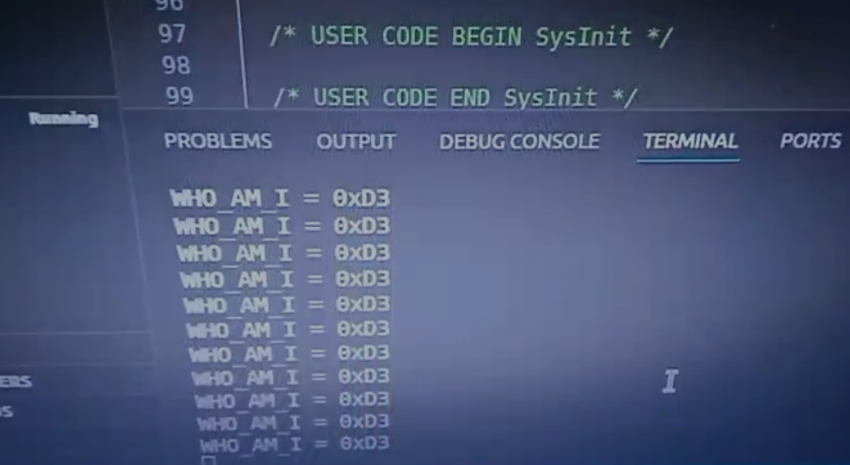

TASK 2:
// typedef enum {
// SPI_STATE_IDLE = 0,
// SPI_STATE_TX_DONE,
// SPI_STATE_RX_DONE
// } SPI_State_t;
// volatile SPI_State_t spiState = SPI_STATE_IDLE;
// uint8_t t2_tx_buf[1];
// uint8_t t2_rx_buf[1];
// volatile int8_t t2_temperature = 0;
// void gyro_read_temp_start(void);
// void HAL_SPI_TxCpltCallback(SPI_HandleTypeDef *hspi);
// void HAL_SPI_RxCpltCallback(SPI_HandleTypeDef *hspi);
// void gyro_read_temp_start(void)
// {
// t2_tx_buf[0] = SPI_READ | OUT_TEMP;
// spiState = SPI_STATE_IDLE;
// GYRO_CS_LOW();
// HAL_SPI_Transmit_IT(&hspi1, t2_tx_buf, 1);
// }
//
// void HAL_SPI_TxCpltCallback(SPI_HandleTypeDef *hspi)
// {
// if (hspi->Instance == SPI1)
// {
// spiState = SPI_STATE_TX_DONE;
// HAL_SPI_Receive_IT(&hspi1, t2_rx_buf, 1);
// }
// }
//
// void HAL_SPI_RxCpltCallback(SPI_HandleTypeDef *hspi)
// {
// if (hspi->Instance == SPI1)
// {
// GYRO_CS_HIGH();
// t2_temperature = (int8_t)t2_rx_buf[0];
// spiState = SPI_STATE_RX_DONE;
// }}
// GYRO_CS_HIGH();
// HAL_Delay(10);
// gyro_init_t2(); /* Task 2 used its own init writing only CTRL_REG1=0x0F */
// HAL_Delay(100);
// -- while loop was: gyro_read_temp_start(); wait spiState; transmit; delay
RESULTS:
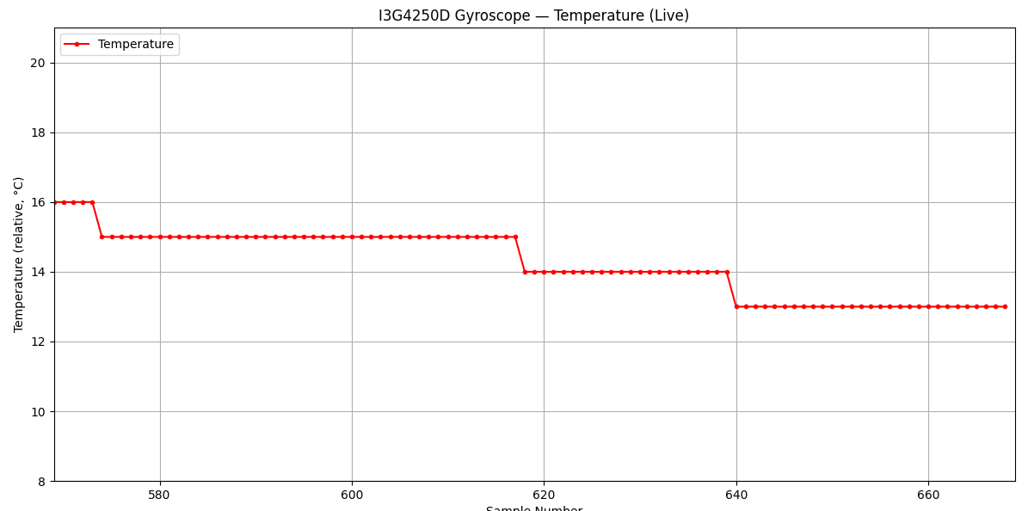

TASK 3:
static uint8_t rx_buf[6];
static int8_t temp_raw;
static int16_t x_raw, y_raw, z_raw;
static char uart_buf[64];
/* USER CODE END PV */
void SystemClock_Config(void);
static void MX_GPIO_Init(void);
static void MX_I2C1_Init(void);
static void MX_SPI1_Init(void);
static void MX_USART2_UART_Init(void);
static void MX_USB_PCD_Init(void);
static void gyro_write_reg(uint8_t reg, uint8_t val);
static uint8_t gyro_read_reg(uint8_t reg);
static void gyro_init(void);
static void gyro_read_all(void);
static int write_dps(char *buf, int32_t raw);
static void gyro_write_reg(uint8_t reg, uint8_t val)
{
uint8_t tx[2] = { reg & 0x3F, val };
GYRO_CS_LOW();
HAL_SPI_Transmit(&hspi1, tx, 2, HAL_MAX_DELAY);
GYRO_CS_HIGH();
}

static uint8_t gyro_read_reg(uint8_t reg)
{
uint8_t cmd = SPI_READ | (reg & 0x3F);
uint8_t data = 0;
GYRO_CS_LOW();
HAL_SPI_Transmit(&hspi1, &cmd, 1, HAL_MAX_DELAY);
HAL_SPI_Receive (&hspi1, &data, 1, HAL_MAX_DELAY);
GYRO_CS_HIGH();
return data;
}

static void gyro_init(void)
{
gyro_write_reg(CTRL_REG1, CTRL_REG1_VAL); /* Power on, enable axes */
gyro_write_reg(CTRL_REG4, CTRL_REG4_VAL); /* ±245 dps full scale */
}
static void gyro_read_all(void)
{
/* Read temperature */
temp_raw = (int8_t)gyro_read_reg(OUT_TEMP);

/* Burst read 6 bytes: OUT_X_L through OUT_Z_H using auto-increment */
uint8_t cmd = SPI_READ | SPI_AUTO_INC | OUT_X_L; /* 0xE8 */
GYRO_CS_LOW();
HAL_SPI_Transmit(&hspi1, &cmd, 1, HAL_MAX_DELAY);
HAL_SPI_Receive (&hspi1, rx_buf, 6, HAL_MAX_DELAY);
GYRO_CS_HIGH();

/* Merge low and high bytes (little-endian) */
x_raw = (int16_t)((rx_buf[1] << 8) | rx_buf[0]);
y_raw = (int16_t)((rx_buf[3] << 8) | rx_buf[2]);
z_raw = (int16_t)((rx_buf[5] << 8) | rx_buf[4]);
}
static int write_dps(char *buf, int32_t raw)
{
int32_t scaled = (raw * 875L) / 100L; /* units of 0.01 dps */
int negative = (scaled < 0);
if (negative) scaled = -scaled;

int32_t whole = scaled / 100;
int32_t frac = scaled % 100;

if (negative)
return sprintf(buf, "-%ld.%02ld", (long)whole, (long)frac);
else
return sprintf(buf, "%ld.%02ld", (long)whole, (long)frac);
}
int main(void)
{
/* USER CODE BEGIN 1 */
/* USER CODE END 1 */

HAL_Init();
SystemClock_Config();

MX_GPIO_Init();
MX_I2C1_Init();
MX_SPI1_Init();
MX_USART2_UART_Init();
MX_USB_PCD_Init();
GYRO_CS_HIGH();
HAL_Delay(10);
gyro_init();
HAL_Delay(100);

/* USER CODE END 2 */

/* USER CODE BEGIN WHILE */
while (1)
{
/* USER CODE END WHILE */
/* USER CODE BEGIN 3 */

gyro_read_all();

char xs[12], ys[12], zs[12];
write_dps(xs, x_raw);
write_dps(ys, y_raw);
write_dps(zs, z_raw);

int len = sprintf(uart_buf, "%d, %s, %s, %s\n",
(int)temp_raw, xs, ys, zs);

HAL_UART_Transmit(&huart2, (uint8_t *)uart_buf, (uint16_t)len, HAL_MAX_DELAY);

HAL_Delay(100);
}
/* USER CODE END 3 */
}
RESULT:
